**Twitter Sentiment Analysis using Machine Learning**

**LIST OF CONTENTS**

1. **INTRODUCTION**
   1. INTRODUCTION TO PROJECT
   2. PURPOSE OF THE SYSTEM
   3. PROBLEMS IN EXISTING SYSTEM
   4. SOLUTION OF THESE PROBLEMS
2. **SYSTEM ANALYSIS**
   1. INTRODUCTION
   2. STUDY OF THE SYSTEM
   3. HARDWARE AND SOFTWARE REQUIRMENTS
   4. PROPOSED SYSTEM
   5. INPUT AND OUTPUT
   6. PROCESS MODULES USED WITH JUSTIFICATION
3. **FEASIBILITY REPORT**
   1. TECHNICAL FEASIBILITY
   2. OPERATIONAL FEASIBILITY
   3. ECONOMICAL FEASIBILTY
4. **SOFTWARE REQUIREMENT SPECIFICATIONS**
   1. FUNCTIONAL REQUIREMENTS
   2. PERFORMANCE REQUIREMENTS

**5. SELECTED SOFTWARE**

5.1. INTRODUCTION TO PYTHON

5.2. PYTHON

**6. SYSTEM DESIGN**

6.1. INTRODUCTION

6.2. SYSTEM WORK FLOW

6.3. UML DIAGRAMS

**7. SYSTEM TESTING AND VALIDATION**

7.1.INTRODUCTION

7.2. STRATEGIC APPROACH OF SOFTWARE TESTING

7.3. UNIT TESTING

**8. SYSTEM SECURITY**

8.1. INTRODUCTION

* 1. SECURITY IN SOFTWARE

**9. OUTPUT SCREENS**

**10. CONCLUSION**

**11. BIBLIOGRAPHY**

**Abstract**

Twitter is a micro-blogging website which provides platform for people to share and express their views about topics, happenings, products and other services. Tweets can be classified into different classes based on their relevance with the topic searched. Various Machine Learning algorithms are currently employed in classification of tweets into positive and negative classes based on their sentiments, such as Baseline, Naive Bayes Classifier, etc. This paper contains implementation of Naive Bayes using sentiment140 training data using twitter database and propose a method to improve classification . Use of Lemmatization along with Naive Bayes can improve accuracy of classification of tweets, by providing positivity, negativity and objectivity score of words present in tweets. For actual implementation of this system python with machine learning and python-twitter data set are used.

**PROBLEM STATEMENT:**

* Now a day's social media became so popular that it has a significance impact on trade and marketing. People share their precious views, opinion, experiences on social sites so that others can get benefit from these. Twitter is one of such platform where common people shares their reviews in short blogs i.e. in 140 characters. These reviews can be for anything like any product or service such as movie, stock market, schools, colleges, politics and much more. Here, people shares the unbiased opinions about anything they wanted, that's why one can consider these reviews as more generalized and real one

**OBJECTIVE:**

we address the problem of sentiment classification on twitter dataset. We use a number of text preprocessing and Naive Bayes classifier methods to perform sentiment analysis. In the end, we use a accuracy classifying method of different text preprocessing to achieve the classification accuracy of 76.78% on Kaggle public leaderboard.

**1. INTRODUCTION**

**1.1 INTRODUCTION:**

Now a day's social media became so popular that it has a significance impact on trade and marketing. People share their precious views, opinion, experiences on social sites so that others can get benefit from these. Twitter is one of such platform where common people shares their reviews in short blogs i.e. in 140 characters. These reviews can be for anything like any product or service such as movie, stock market, schools, colleges, politics and much more. Here, people shares the unbiased opinions about anything they wanted, that's why one can consider these reviews as more generalized and real one. There are five basic steps involved to implement this whole system- first step is selection of training data which is selected on the basis of type of problem, second step is preprocessing of training data which means removing irrelevant information like URLs, user names, slang words, symbols etc., third step is to establish connection with twitter learning algorithms like Naive Bayes, Support Vector Machine are used for the classification of tweets into different classes and in the final step results are displayed on the basis of polarities of tweets after their classification. SentiWordNet2 is lexical resource which is broadly used for opinion mining and it provides sentiment score to each synset of WordNet. These score are of three types; positivity score, negativity score and objectivity score. So instead of using Naive Bayes in traditional way, these scores can be taken into account so that more accuracy can be attained. In third section, all theoretical work done is explained like how to gather resources, their integration and their simulation, in fourth section traditional method of classification is compared with proposed method of classification using the help of SentiWordNet, after that future scope, appendix and references are provided

**2. LITERATURE SURVEY**

Numerous research work has been already done in field of sentiment analysis. But the informal tone of tweets has always been a challenge for the analysis. Because of the unbiased nature of tweets , twitter database has been in lime light for sentiment analysis of movies , products , popularity or anything of that sort. Sentiment analysis has given way to a wide range of researches ranging from document level classification (Tirney , 2002 ; Pang and Lee , 2004 ) to sentence level Hu and Liu ,2004 ; Kim and Hovy ,2004) leading to phrases ( Esuli and Sebastini ,2006 ) . Classifying tweets into positive and negative classes using distant supervision was presented by Alec Go,Richa Bhavani and Lei Huang , 2009 .They presented an approach for automatically classifying the sentiment of twitter messages with respect to a query term . They presented results of machine learning algorithms (Naive Bayes , maximaum Entropy , and SVM) for classification . Use of linguistic features for detecting sentiment of twitter messages was investigated by Efthymios Kouloumis , Theresa Wilson and Johanna Moore (2011). they used hashtagged dataset(HASH) for development and training .The main aim of this paper was to take a supervised approach using the existing hashtags in twitter data for building training data . Hassan Saif , Yulan He and Harith Alani , 2012 explained an approach of adding semantics as additional features into training set for sentiment analysis. For each extracted entity its semantic concepts were added as an additional feature and the correlation of the representative concepts with positive / negative sentiments were calculated . Use of sentiwordnet as a lexical resource for sentiment analysis (Stefano Baccianella, Andrea Esuli , and Fabrizio Sebastiani ,) added to the efficiency of previous traditional methods of classification . This paper explained how use of SENTIWORDNET 3.0 improves efficiency of classifications with respect to previous versions of WORDNET and SENTIWORDNET.

Go et al. proposed a solution by using distant supervision, in which their training data consisted of tweets with emoticons. This approach was initially introduced by Read. The emoticons served as noisy labels. They build models using Naive Bayes, MaxEnt and Support Vector Machines (SVM). Their feature space consisted of unigrams, bigrams and POS. The reported that SVM outperformed other models and that unigram were more effective as features. Pak and Paroubek have done similar work but classify the tweets as objective, positive and negative.

In order to collect a corpus of objective posts, they retrieved text messages from Twitter accounts of popular newspapers and magazine, such as “New York Times”, “Washington Posts” etc. Their classifier is based on the multinomial Naïve Bayes classifier that uses N-gram and POS-tags as features. Barbosa et al. too classified tweets as objective or subjective and then the subjective tweets were classified as positive or negative. The feature space used included features of tweets like retweet, hashtags, link, punctuation and exclamation marks in conjunction with features like prior polarity of words and POS of words. Mining for entity opinions in Twitter, Batra and Rao used a dataset of tweets spanning two months starting from June 2009. The dataset has roughly 60 million tweets.

**3. SYSTEM ANALYSIS**

The Systems Development Life Cycle (SDLC), or Software Development Life Cycle in [systems engineering](http://en.wikipedia.org/wiki/Systems_engineering), [information systems](http://en.wikipedia.org/wiki/Information_systems) and [software engineering](http://en.wikipedia.org/wiki/Software_engineering), is the process of creating or altering systems, and the models and [methodologies](http://en.wikipedia.org/wiki/Methodologies) that people use to develop these systems. In software engineering the SDLC concept underpins many kinds of [software development methodologies](http://en.wikipedia.org/wiki/Software_development_methodologies).

**3.1 EXISTING SYSTEM**:

* . Classifying tweets into positive and negative classes using distant supervision was presented by Alec Go,Richa Bhayani and Lei Huang , 2009 .They presented an approach for automatically classifying the sentiment of twitter messages with respect to a query term .
* an approach of adding semantics as additional features into training set for sentiment analysis. For each extracted entity its semantic concepts were added as an additional feature and the correlation of the representative concepts with positive / negative sentiments were calculated

**Disadvantages:**

* Numerous research work has been already done in field of sentiment analysis. But the informal tone of tweets has always been a challenge for the analysis. Because of the unbiased nature of tweets , twitter database has been in lime light for sentiment analysis of movies , products , popularity or anything of that sort

**3.3 PROPOSED SYSTEM:**

* In proposed system, we will attempt to conduct sentiment analysis on “tweets” using various different text preprocessing and Naïve Bayes Classifier algorithm. We attempt to classify the polarity of the tweet where it is either positive or negative. If the tweet has both positive and negative elements, the more dominant sentiment should be picked as the final label.
* We use the dataset from Kaggle which was crawled and labeled positive/negative. The data provided comes with emoticons, usernames and hashtags which are required to be processed and converted into a standard form. We also need to extract useful features from the text such unigrams bigrams and trigrams which is a form of representation of the “tweet”. We use Naïve-Bayes Classifier to conduct sentiment analysis using the extracted features. However, just relying on an individual model did not give a high accuracy.

**Advantages:**

* Sentiment analysis also is used to monitor and analyse social phenomena, for the spotting of potentially dangerous situations and determining the general mood of the blogosphere.
* In political field, it is used to keep track of political view, to detect consistency and inconsistency between statements and actions at the government level. It can be used to predict election results as well!

**Methodology**

**What is Sentiment Analysis?**

Sentiment analysis (a.k.a opinion mining) is the automated process of identifying and extracting the subjective information that underlies a text. This can be either an opinion, a judgment, or a feeling about a particular topic or subject. The most common type of sentiment analysis is called ‘polarity detection’ and consists in classifying a statement as ‘positive’, ‘negative’ or ‘neutral’.

* For example, let’s take this sentence: “I don’t find the app useful: it’s really slow and constantly crashing”. A sentiment analysis model would automatically tag this as Negative.

A sub-field of Natural Language Processing (NLP), sentiment analysis has been getting a lot of attention in recent years due to its many exciting applications in a variety of fields, ranging from business to political studies.

Thanks to sentiment analysis, companies can understand the reputation of their brand. By analyzing social media posts, product reviews, customer feedback, or NPS responses (among other sources of unstructured business data), they can be aware of how their customers feel about their product. They can also track specific topics and get relevant insights on how people are talking about those topics.

Sentiment analysis is particularly useful for social media monitoring because it goes beyond metrics that focus on the number of likes or retweets, and provides a qualitative point of view.

Let’s say a company has just launched a new product feature and you notice a sharp increase in mentions on Twitter. However, receiving tons of mentions does not necessarily mean a good thing. Are customers tweeting more because they are expressing good things about this new product feature? Or, are customers actually complaining about the feature having lots of bugs? Performing Twitter sentiment analysis can be an excellent way to understand the tone of those mentions and obtain real-time insights on how users are perceiving your new product.

**Sentiment analysis uses:**

Sentiment analysis is extremely useful in social media monitoring as it allows us to gain an overview of the wider public opinion behind certain topics. Social media monitoring tools like Brandwatch Analytics make that process quicker and easier than ever before, thanks to real-time monitoring capabilities.

The applications of sentiment analysis are broad and powerful. The ability to extract insights from social data is a practice that is being widely adopted by organisations across the world.

Shifts in sentiment on social media have been shown to correlate with shifts in the stock market.

The Obama administration used sentiment analysis to gauge public opinion to policy announcements and campaign messages ahead of 2012 presidential election. Being able to quickly see the sentiment behind everything from forum posts to news articles means being better able to strategise and plan for the future.

It can also be an essential part of your market research and customer service approach. Not only can you see what people think of your own products or services, you can see what they think about your competitors too. The overall customer experience of your users can be revealed quickly with sentiment analysis, but it can get far more granular too.

The ability to quickly understand consumer attitudes and react accordingly is something that Expedia Canada took advantage of when they noticed that there was a steady increase in negative feedback to the music used in one of their television adverts.

**Understanding Sentiment: Tweet**

Sentiment analysis conducted by the brand revealed that the music played on the commercial had become incredibly irritating after multiple airings, and consumers were flocking to social media to vent their frustrations.

A couple of weeks after the advert first aired, over half of online conversation about the campaign was negative.

Rather than chalking up the advert as a failure, Expedia was able to address the negative sentiment in a playful and self-knowing way by airing a new version of the advert which featured the offending violin being smashed.

Sentiment analysis is the automated process of analyzing text data and classifying opinions as negative, positive or neutral. Usually, besides identifying the opinion, these systems extract attributes of the expression e.g.:

* Polarity: if the speaker express a positive or negative opinion,
* Subject: the thing that is being talked about,
* Opinion holder: the person, or entity that expresses the opinion.

**step A: Preparing The Test Set**

* Step A.1: Getting the authentication credentials
* Step A.2: Authenticating our Python script
* Step A.3: Creating the function to build the Test set

**step B: Preparing The Training Set**

**step C: Pre-processing BOT Tweets in The Data Sets**

**step D: Naive Bayes Classifier**

* Step D.1: Building the vocabulary
* Step D.2: Matching tweets against our vocabulary
* Step D.3: Building our feature vector
* Step D.4: Training the classifier

**Step E: Testing The Model**

# Dataset

The data given is in the form of a comma-separated values files with tweets and their corresponding sentiments. The training dataset is a csv file of type tweet_id, bot tweets where the tweet_id is a unique integer identifying the tweet, sentiment is either 1 (positive) or 0 (negative), and tweet is the tweet enclosed in "". We will use this single dataset to cross validate our model.

The dataset is a mixture of words, emoticons, symbols, URLs, hashtags and references to people. Words and emoticons contribute to predicting the sentiment, but URLs and references to people don’t. Therefore, URLs and references can be ignored. The words are also a mixture of misspelled words, extra punctuation, and words with many repeated letters. The tweets, therefore, have to be preprocessed to standardize the dataset.

**4. IMPLEMENTATION**

**4.1 INTRODUCTION**

**Software Development Life Cycle:**

There is various software development approaches defined and designed which are used/employed during development process of software, these approaches are also referred as "Software Development Process Models". Each process model follows a particular life cycle in order to ensure success in process of software development.

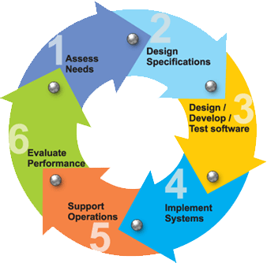

**Requirements:**

Business requirements are gathered in this phase.  This phase is the main focus of the project managers and stake holders.  Meetings with managers, stake holders and users are held in order to determine the requirements.  Who is going to use the system?  How will they use the system?  What data should be input into the system?  What data should be output by the system?  These are general questions that get answered during a requirements gathering phase.  This produces a nice big list of functionality that the system should provide, which describes functions the system should perform, business logic that processes data, what data is stored and used by the system, and how the user interface should work.  The overall result is the system as a whole and how it performs, not how it is actually going to do it.

**Design:**

The software system design is produced from the results of the requirements phase.  Architects have the ball in their court during this phase and this is the phase in which their focus lies.  This is where the details on how the system will work is produced.  Architecture, including hardware and software, communication, software design (UML is produced here) are all part of the deliverables of a design phase.

**Implementation:**

Code is produced from the deliverables of the design phase during implementation, and this is the longest phase of the software development life cycle.  For a developer, this is the main focus of the life cycle because this is where the code is produced.  Implementation my overlap with both the design and testing phases.  Many tools exists (CASE tools) to actually automate the production of code using information gathered and produced during the design phase.

**Testing:**

During testing, the implementation is tested against the requirements to make sure that the product is actually solving the needs addressed and gathered during the requirements phase.  Unit tests and system/acceptance tests are done during this phase.  Unit tests act on a specific component of the system, while system tests act on the system as a whole.

So in a nutshell, that is a very basic overview of the general software development life cycle model.  Now let’s delve into some of the traditional and widely used variations.

**SDLC METHDOLOGIES:**

This document play a vital role in the development of life cycle (SDLC) as it describes the complete requirement of the system. It means for use by developers and will be the basic during testing phase. Any changes made to the requirements in the future will have to go through formal change approval process.

SPIRAL MODEL was defined by Barry Boehm in his 1988 article, “A spiral Model of Software Development and Enhancement. This model was not the first model to discuss iterative development, but it was the first model to explain why the iteration models.

As originally envisioned, the iterations were typically 6 months to 2 years long. Each phase starts with a design goal and ends with a client reviewing the progress thus far. Analysis and engineering efforts are applied at each phase of the project, with an eye toward the end goal of the project.

**The following diagram shows how a spiral model acts like:**

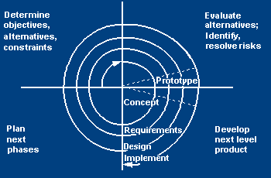

**The steps for Spiral Model can be generalized as follows:**

* The new system requirements are defined in as much details as possible. This usually involves interviewing a number of usersrepresenting all the external or internal users and other aspects of the existing system.
* A preliminary design is created for the new system.
* A first prototype of the new system is constructed from the preliminary design. This is usually a scaled-down system, and represents an approximation of the characteristics of the final product.
* A second prototype is evolved by a fourfold procedure:

1. Evaluating the first prototype in terms of its strengths, weakness, and risks.
2. Defining the requirements of the second prototype.
3. Planning a designing the second prototype.
4. Constructing and testing the second prototype.

* At the customer option, the entire project can be aborted if the risk is deemed too great. Risk factors might involve development cost overruns, operating-cost miscalculation, or any other factor that could, in the customer’s judgment, result in a less-than-satisfactory final product.
* The existing prototype is evaluated in the same manner as was the previous prototype, and if necessary, another prototype is developed from it according to the fourfold procedure outlined above.
* The preceding steps are iterated until the customer is satisfied that the refined prototype represents the final product desired.
* The final system is constructed, based on the refined prototype.
* The final system is thoroughly evaluated and tested. Routine maintenance is carried on a continuing basis to prevent large scale failures and to minimize down time.

**2.2 STUDY OF THE SYSTEM**

In the flexibility of uses the interface has been developed a graphics concepts in mind, associated through a browser interface. The GUI’s at the top level has been categorized as follows

1. Administrative User Interface Design
2. The Operational and Generic User Interface Design

The administrative user interface concentrates on the consistent information that is practically, part of the organizational activities and which needs proper authentication for the data collection. The Interface helps the administration with all the transactional states like data insertion, data deletion, and data updating along with executive data search capabilities.

The operational and generic user interface helps the users upon the system in transactions through the existing data and required services. The operational user interface also helps the ordinary users in managing their own information helps the ordinary users in managing their own information in a customized manner as per the assisted flexibilities.

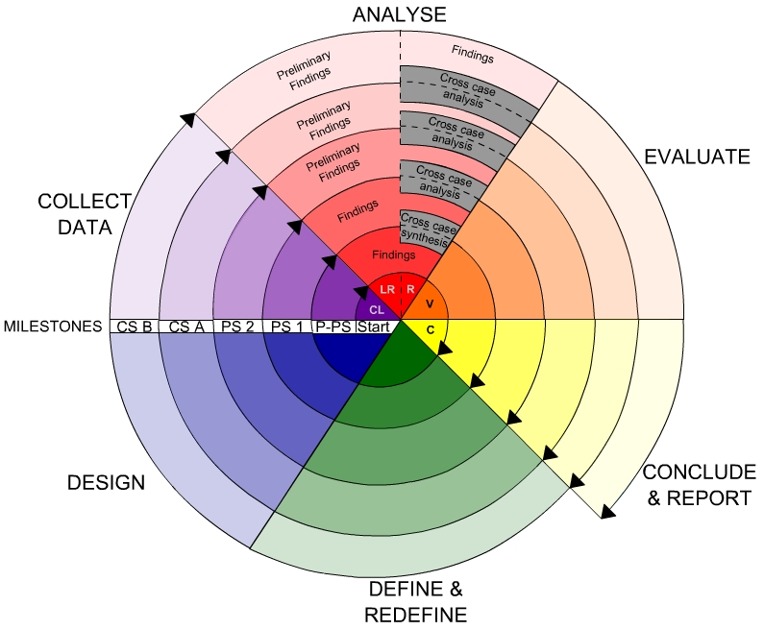

**2.3. INPUT AND OUTPUT**

**2.3.1.INPUT DESIGN**

Input design is a part of overall system design. The main objective during the input design is as given below:

* To produce a cost-effective method of input.
* To achieve the highest possible level of accuracy.
* To ensure that the input is acceptable and understood by the user.

**INPUT STAGES:**

The main input stages can be listed as below:

* Data recording
* Data transcription
* Data conversion
* Data verification
* Data control
* Data transmission
* Data validation
* Data correction

**INPUT TYPES:**

It is necessary to determine the various types of inputs. Inputs can be categorized as follows:

* External inputs, which are prime inputs for the system.
* Internal inputs, which are user communications with the system.
* Operational, which are computer department’s communications to the system?
* Interactive, which are inputs entered during a dialogue.

**INPUTMEDIA:**

At this stage choice has to be made about the input media. To conclude about the input media consideration has to be given to;

* Type of input
* Flexibility of format
* Speed
* Accuracy
* Verification methods
* Rejection rates
* Ease of correction
* Storage and handling requirements
* Security
* Easy to use
* Portability

Keeping in view the above description of the input types and input media, it can be said that most of the inputs are of the form of internal and interactive. As

Input data is to be the directly keyed in by the user, the keyboard can be considered to be the most suitable input device.

**2.3.2.OUTPUT DESIGN**

Outputs from computer systems are required primarily to communicate the results of processing to users. They are also used to provide a permanent copy of the results for later consultation. The various types of outputs in general are:

* External Outputs, whose destination is outside the organization
* Internal Outputs whose destination is within organization and they are the
* User’s main interface with the computer.
* Operational outputs whose use is purely within the computer department.
* Interface outputs, which involve the user in communicating directly.

**OUTPUT DEFINITION:**

# The outputs should be defined in terms of the following points:

* + - Type of the output
    - Content of the output
    - Format of the output
    - Location of the output
    - Frequency of the output
    - Volume of the output
    - Sequence of the output

It is not always desirable to print or display data as it is held on a computer. It should be decided as which form of the output is the most suitable.

**3. Fundamental Concepts on (Domain)**

**What is Cloudera?**

Cloudera is revolutionizing enterprise data management by offering the first unified Platform for Big Data: The Enterprise Data Hub. Cloudera offers enterprises one place to store, process, and analyze all their data, empowering them to extend the value of existing investments while enabling fundamental new ways to derive value from their data.

**Why do customers choose Cloudera?**

Cloudera was the first commercial provider of python-related software and services and has the most customers with enterprise requirements, and the most experience supporting them, in the industry. Cloudera’s combined offering of differentiated software (open and closed source), support, training, professional services, and indemnity brings customers the greatest business value, in the shortest amount of time, at the lowest TCO.

**Data Mining:**

There is a huge amount of data available in the Information Industry. This data is of no use until it is converted into useful information. It is necessary to analyze this huge amount of data and extract useful information from it. Extraction of information is not the only process we need to perform; data mining also involves other processes such as Data Cleaning, Data Integration, Data Transformation, Data Mining, Pattern Evaluation and Data Presentation. Once all these processes are over, we would be able to use this information in many applications such as Fraud Detection, Market Analysis, Production Control, Science Exploration, etc.

What is Data Mining?

Data Mining is defined as extracting information from huge sets of data. In other words, we can say that data mining is the procedure of mining knowledge from data. The information or knowledge extracted so can be used for any of the following applications:

Market Analysis

Fraud Detection

Customer Retention

Production Control

Science Exploration

Data Mining Applications

Data mining is highly useful in the following domains: Market Analysis and Management

Corporate Analysis

& Risk Management Fraud Detection

Apart from these, data mining can also be used in the areas of production control, customer retention, science exploration, sports, astrology, and Internet Web Surf-Aid

Market Analysis and Management

Listed below are the various fields of market where data mining is used: Customer Profiling - Data mining helps determine what kind of people buy what kind of products.

Identifying Customer Requirements - Data mining helps in identifying thebest products for different customers. It uses prediction to find the factors that may attract new customers.

Cross Market Analysis - Data mining performs Association/correlations between product sales.

Target Marketing - Data mining helps to find clusters of model customers who share the same characteristics such as interests, spending habits, income, etc.

Determining Customer purchasing pattern - Data mining helps in determining customer purchasing pattern.

Providing Summary Information - Data mining provides us various multidimensional summary reports.

Corporate Analysis andRisk Management

Data mining is used in the following fields of the Corporate Sector: Finance Planning and Asset Evaluation - It involves cash flow analysis and prediction, contingent claim analysis to evaluate assets.

Resource Planning - It involves summarizing and comparing the resources and spending. Competition - It involves monitoring competitors and market directions.

Fraud Detection

Data mining is also used in the fields of credit card services and telecommunication to detect frauds. In fraud telephone calls, it helps to find the destination of the call, duration of the call, time of the day or week, etc. It also analyzes the patterns that deviate from expected norms.

Data mining essential step in the process of knowledge discovery

1. Data cleaning (to remove noise and inconsistent data)

2. Data integration (where multiple data sources may be combined)

3. Data selection (where data relevant to the analysis task are retrieved from the database)

4. Data transformation (where data are transformed or consolidated into forms appropriate for mining by performing summary or aggregation operations, for instance)

5. Data mining (an essential process where intelligent methods are applied in order to extract data patterns)

6. Pattern evaluation (to identify the truly interesting patterns representing knowledge based on some interestingness measures)

7. Knowledge presentation (where visualization and knowledge representation techniques are used to present the mined knowledge to the user)

Based on this view, the architecture of a typical data mining system may have the following major components

Database, data warehouse, World Wide Web, or other information repository: This is one or a set of databases, data warehouses, spreadsheets, or other kinds of information repositories.

Data cleaning and data integration techniques may be performed on the data. Database or data warehouse server: The database or data warehouse server is responsible for fetching the relevant data, based on the user’s data mining request.

Knowledge base: This is the domain knowledge that is used to guide the search or evaluate the interestingness of resulting patterns. Such knowledge can include concept hierarchies, used to organize attributes or attribute values into different levels of abstraction. Knowledge such as user beliefs, which can be used to assess a pattern’s interestingness based on its unexpectedness, may also be included. Other examples of domain knowledge are additional interestingness constraints or thresholds, and metadata (e.g., describing data from multiple heterogeneous sources).

Data mining engine: This is essential to the data mining system and ideally consists of a set of functional modules for tasks such as characterization, association and correlation analysis, classification, prediction, cluster analysis, outlier analysis, and evolution analysis.

Pattern evaluation module: This component typically employs interestingness measures and interacts with the data mining modules so as to focus the search toward interesting patterns. It may use interestingness thresholds to filter out discovered patterns. Alternatively, the pattern evaluation module may be integrated with the mining module, depending on the implementation of the data mining method used.

For efficient data mining, it is highly recommended to push the evaluation of pattern interestingness as deep as possible into the mining process so as to confine the search to only the interesting patterns.

User interface: This module communicates between users and the data mining system, allowing the user to interact with the system by specifying a data mining query or task, providing information to help focus the search, and performing exploratory data mining based on the intermediate data mining results. In addition, this component allows the user to browse database and data warehouse schemas or data structures, evaluate mined patterns, and visualize the patterns in different forms.

**DATA MINING ON WHAT KIND OF DATA?**

**RELATIONAL DATABASES:**

A database system, also called a database management system (DBMS), consists of a collection of interrelated data, known as a database, and a set of software programs to manage and access the data A relational database is a collection of tables, each of which is assigned a unique name. Each table consists of a set of attributes (columns or fields) and usually stores a large set of tuples (records or rows)

Each tuple in a relational table represents an object identified by a unique key and described by a set of attribute values A semantic data model, such as an entity-relationship (ER) data model, is often constructed for relational databases. An ER data model represents the database as a set of entities and their relationships Relational data can be accessed by database queries written in a relational query language, such as SQL

**DATA WAREHOUSES:**

A data warehouse is a repository of information collected from multiple sources, stored under a unified schema, and that usually resides at a single site Data warehouses are constructed via a process of data cleaning, data integration, data transformation, data loading, and periodic data refreshing

**OBJECT-RELATIONAL DATABASES:**

Based on an object-relational data model Extends the relational model by providing a rich data type for handling complex objects and object orientation Objects that share a common set of properties can be grouped into an object class. Each object is an instance of its class. Object classes can be organized into class/subclass hierarchies

**ADVANCED DATA AND INFORMATION SYSTEMS:**

With the progress of database technology, various kinds of advanced data and information systems have emerged and are undergoing development to address the requirements of new applications handling spatial/temporal data (such as maps) engineering design data (such as the design of buildings, system components, or integrated circuits) hypertext and multimedia data (including text, image, video, and audio data) time-related data (such as historical records or stock exchange data) stream data (such as video surveillance and sensor data, where data flow in and out like streams) the World Wide Web (a huge, widely distributed information repository made available by the Internet)

**THE WORLD WIDE WEB:**

The World Wide Web and its associated distributed information services, such as Yahoo! and Google provide rich, worldwide, on-line information services, where data objects are linked together to facilitate interactive access Capturing user access patterns in such distributed information environments is called Web usage mining (or Weblog mining)

Database or data warehouse server responsible for fetching the relevant data, based on the user’s data mining request can be decouples/loose coupled/tightly coupled with the database layer

Knowledge base the domain knowledge that is used to guide the search or evaluate the interestingness of resulting patterns interestingness constraints or thresholds, metadata, concept hierarchies, etc.

Data mining engine this is essential to the data mining system and ideally consists of a set of functional modules for tasks such as characterization, association and correlation analysis, classification, prediction, cluster analysis, outlier analysis, and evolution analysis query languages (DMQL) based on mining primitives to access the data

Pattern evaluation module interacts with the data mining modules so as to focus the search toward interesting patterns may use interestingness thresholds to filter out discovered patterns may be integrated with the mining module

User interface communicates between users and the data mining system allows the user to interact with the system by specifying a data mining query or task, providing information to help focus the search, and performing exploratory data mining based on the intermediate data mining results allows the user to browse database and data warehouse schemas or data structures, evaluate mined patterns, and visualize the patterns in different forms

**4. System Analysis**

The **Systems Development Life Cycle (SDLC)**, or Software Development Life Cycle in [systems engineering](http://en.wikipedia.org/wiki/Systems_engineering), [information systems](http://en.wikipedia.org/wiki/Information_systems) and [software engineering](http://en.wikipedia.org/wiki/Software_engineering), is the process of creating or altering systems, and the models and [methodologies](http://en.wikipedia.org/wiki/Methodologies) that people use to develop these systems.

In software engineering the SDLC concept underpins many kinds of [software development methodologies](http://en.wikipedia.org/wiki/Software_development_methodologies). These methodologies form the framework for planning and controlling the creation of an information system the [software development process](http://en.wikipedia.org/wiki/Software_development_process).

**SOFTWARE MODEL OR ARCHITECTURE ANALYSIS:**

Structured project management techniques (such as an SDLC) enhance management’s control over projects by dividing complex tasks into manageable sections. A software life cycle model is either a descriptive or prescriptive characterization of how software is or should be developed. But none of the SDLC models discuss the key issues like Change management, Incident management and Release management processes within the SDLC process, but, it is addressed in the overall project management. In the proposed hypothetical model, the concept of user-developer interaction in the conventional SDLC model has been converted into a three dimensional model which comprises of the user, owner and the developer. In the proposed hypothetical model, the concept of user-developer interaction in the conventional SDLC model has been converted into a three dimensional model which comprises of the user, owner and the developer. The ―one size fits all‖ approach to applying SDLC methodologies is no longer appropriate. We have made an attempt to address the above mentioned defects by using a new hypothetical model for SDLC described elsewhere. The drawback of addressing these management processes under the overall project management is missing of key technical issues pertaining to software development process that is, these issues are talked in the project management at the surface level but not at the ground level.

**2.5Functional requirements**

Outputs from computer systems are required primarily to communicate the results of processing to users. They are also used to provide a permanent copy of the results for later consultation. The various types of outputs in general are:

* External Outputs, whose destination is outside the organization,.
* Internal Outputs whose destination is within organization and they are the
* User’s main interface with the computer.
* Operational outputs whose use is purely within the computer department.
* Interface outputs, which involve the user in communicating directly.
* Understanding user’s preferences, expertise level and his business requirements through a friendly questionnaire.
* Input data can be in four different forms - Relational DB, text files, .xls and xml files. For testing and demo you can choose data from any domain. User-B can provide business data as input.

**Non-Functional Requirements:**

1. Secure access of confidential data (user’s details). SSL can be used.
2. 24 X 7 availability.
3. Better component design to get better performance at peak time
4. Flexible service based architecture will be highly desirable for future extension

**FEASIBILITY STUDY**

**FEASIBILITY STUDY:**

Preliminary investigation examine project feasibility, the likelihood the system will be useful to the organization. The main objective of the feasibility study is to test the Technical, Operational and Economical feasibility for adding new modules and debugging old running system. All system is feasible if they are unlimited resources and infinite time. There are aspects in the feasibility study portion of the preliminary investigation:

* Technical Feasibility
* Economical Feasibility
* Operation Feasibility

**2.1. Technical Feasibility:**

In the feasibility study first step is that the organization or company has to decide that what technologies are suitable to develop by considering existing system.

The technical issue usually raised during the feasibility stage of the investigation includes the following:

* Does the necessary technology exist to do what is suggested?
* Do the proposed equipment have the technical capacity to hold the data required to use the new system?
* Will the proposed system provide adequate response to inquiries, regardless of the number or location of users?
* Can the system be upgraded if developed?
* Are there technical guarantees of accuracy, reliability, ease of access and data security?

Earlier no system existed to cater to the needs of ‘Secure Infrastructure Implementation System’. The current system developed is technically feasible. It is a web based user interface for audit workflow at NIC-CSD. Thus it provides an easy access to the users. The database’s purpose is to create, establish and maintain a workflow among various entities in order to facilitate all concerned users in their various capacities or roles. Permission to the users would be granted based on the roles specified. Therefore, it provides the technical guarantee of accuracy, reliability and security. The software and hard requirements for the development of this project are not many and are already available in-house at NIC or are available as free as open source. The work for the project is done with the current equipment and existing software technology. Necessary bandwidth exists for providing a fast feedback to the users irrespective of the number of users using the system.

Here in this application used the technologies like Visual Studio 2012 and SqlServer 2014. These are free software that would be downloaded from web.

Visual Studio 2013 –it is tool or technology.

**2.2. ECONOMICAL FEASIBILITY**

A system can be developed technically and that will be used if installed must still be a good investment for the organization. In the economical feasibility, the development cost in creating the system is evaluated against the ultimate benefit derived from the new systems. Financial benefits must equal or exceed the costs.

The system is economically feasible. It does not require any addition hardware or software. Since the interface for this system is developed using the existing resources and technologies available at NIC, There is nominal expenditure and economical feasibility for certain.

### Determining Economic Feasibility:

Assessing the economic feasibility of an implementation by performing a cost/benefit analysis, which as its name suggests compares the full/real costs of the application to its full/real financial benefits.  The alternatives should be evaluated on the basis of their contribution to net cash flow, the amount by which the benefits exceed the costs, because the primary objective of all investments is to improve overall organizational performance.

|  |  |  |
| --- | --- | --- |
| **Type** | **Potential Costs** | **Potential Benefits** |
| Quantitative | * Hardware/software upgrades * Fully-burdened cost of labor (salary + benefits) * Support costs for the application * Expected operational costs * Training costs for users to learn the application * Training costs to train developers in new/updated technologies | * Reduced operating costs * Reduced personnel costs from a reduction in staff * Increased revenue from additional sales of your organizations products/services |
| Qualitative | * Increased employee dissatisfaction from fear of change | * Improved decisions as the result of access to accurate and timely information * Raising of existing, or introduction of a new, barrier to entry within your industry to keep competition out of your market * Positive public perception that your organization is an innovator |

 The table includes both qualitative factors, costs or benefits that are subjective in nature, and quantitative factors, costs or benefits for which monetary values can easily be identified.  I will discuss the need to take both kinds of factors into account when performing a cost/benefit analysis.

**2.3. OPERATIONAL FEASIBILITY**

Proposed projects are beneficial only if they can be turned out into information system. That will meet the organization’s operating requirements. Operational feasibility aspects of the project are to be taken as an important part of the project implementation. Some of the important issues raised are to test the operational feasibility of a project includes the following: -

* Is there sufficient support for the management from the users?
* Will the system be used and work properly if it is being developed and implemented?
* Will there be any resistance from the user that will undermine the possible application benefits?

This system is targeted to be in accordance with the above-mentioned issues. Beforehand, the management issues and user requirements have been taken into consideration. So there is no question of resistance from the users that can undermine the possible application benefits.

The well-planned design would ensure the optimal utilization of the computer resources and would help in the improvement of performance status.

Not only must an application make economic and technical sense, it must also make operational sense.

|  |  |
| --- | --- |
| **Operations Issues** | **Support Issues** |
| * What tools are needed to support operations? * What skills will operators need to be trained in? * What processes need to be created and/or updated? * What documentation does operations need? | * What documentation will users be given? * What training will users be given? * How will change requests be managed? |

Very often you will need to improve the existing operations, maintenance, and support infrastructure to support the operation of the new application that you intend to develop.  To determine what the impact will be you will need to understand both the current operations and support infrastructure of your organization and the operations and support characteristics of your new application. To operate this application END-TO-END VMS. The user no need to require any technical knowledge that we are used to develop this project is Asp.net C#.net. That the application providing rich user interface by user can do the operation in flexible manner.

**SELECTED SOFTWARE**

**IMPLEMENTATION ON (PYTHON):**

**What Is A Script?**

Up to this point, I have concentrated on the interactive programming capability of Python.  This is a very useful capability that allows you to type in a program and to have it executed immediately in an interactive mode

**Scripts are reusable:**

Basically, a script is a text file containing the statements that comprise a Python program.  Once you have created the script, you can execute it over and over without having to retype it each time.

**Scripts are editable:**

Perhaps, more importantly, you can make  different versions of the script by modifying the statements from one file to the next using a text editor.  Then you can execute each of the individual versions.  In this way, it is easy to create different programs with a minimum amount of typing.

**You will need a text editor:**

Just about any text editor will suffice for creating Python script files.

You can use Microsoft Notepad, Microsoft WordPad, Microsoft Word, or just about any word processor if you want to.

**Difference between a script and a program**

**Script:** Scripts are distinct from the core code of the application, which is usually written in a different language, and are often created or at least modified by the end-user. Scripts are often interpreted from source code or byte code, where as the applications they control are traditionally compiled to native machine code.

**Program:** The program has an executable form that the computer can use directly to execute the instructions.

The same program in its human-readable source code form, from which executable programs are derived(e.g., compiled)

**Python**

what is Python? Chances you are asking yourself this. You may have found this book because you want to learn to program but don’t know anything about programming languages. Or you may have heard of programming languages like C, C++, C#, or Java and want to know what Python is and how it compares to “big name” languages. Hopefully I can explain it for you.

**Python concepts**

If you not interested in the how and whys of Python, feel free to skip to the next chapter. In this chapter I will try to explain to the reader why I think Python is one of the best languages available and why it’s a great one to start programming with.

• Open source general-purpose language.

• Object Oriented, Procedural, Functional

• Easy to interface with C/ObjC/Java/Fortran

• Easy-ish to interface with C++ (via SWIG)

• Great interactive environment

Python is a high-level, interpreted, interactive and object-oriented scripting language. Python is designed to be highly readable. It uses English keywords frequently where as other languages use punctuation, and it has fewer syntactical constructions than other languages.

* **Python is Interpreted** − Python is processed at runtime by the interpreter. You do not need to compile your program before executing it. This is similar to PERL and PHP.
* **Python is Interactive** − You can actually sit at a Python prompt and interact with the interpreter directly to write your programs.
* **Python is Object-Oriented** − Python supports Object-Oriented style or technique of programming that encapsulates code within objects.
* **Python is a Beginner's Language** − Python is a great language for the beginner-level programmers and supports the development of a wide range of applications from simple text processing to WWW browsers to games.

**History of Python**

Python was developed by Guido van Rossum in the late eighties and early nineties at the National Research Institute for Mathematics and Computer Science in the Netherlands.

Python is derived from many other languages, including ABC, Modula-3, C, C++, Algol-68, SmallTalk, and Unix shell and other scripting languages.

Python is copyrighted. Like Perl, Python source code is now available under the GNU General Public License (GPL).

Python is now maintained by a core development team at the institute, although Guido van Rossum still holds a vital role in directing its progress.

**Python Features**

Python's features include −

* **Easy-to-learn** − Python has few keywords, simple structure, and a clearly defined syntax. This allows the student to pick up the language quickly.
* **Easy-to-read** − Python code is more clearly defined and visible to the eyes.
* **Easy-to-maintain** − Python's source code is fairly easy-to-maintain.
* **A broad standard library** − Python's bulk of the library is very portable and cross-platform compatible on UNIX, Windows, and Macintosh.
* **Interactive Mode** − Python has support for an interactive mode which allows interactive testing and debugging of snippets of code.
* **Portable** − Python can run on a wide variety of hardware platforms and has the same interface on all platforms.
* **Extendable** − You can add low-level modules to the Python interpreter. These modules enable programmers to add to or customize their tools to be more efficient.
* **Databases** − Python provides interfaces to all major commercial databases.
* **GUI Programming** − Python supports GUI applications that can be created and ported to many system calls, libraries and windows systems, such as Windows MFC, Macintosh, and the X Window system of Unix.
* **Scalable** − Python provides a better structure and support for large programs than shell scripting.

Apart from the above-mentioned features, Python has a big list of good features, few are listed below −

* It supports functional and structured programming methods as well as OOP.
* It can be used as a scripting language or can be compiled to byte-code for building large applications.
* It provides very high-level dynamic data types and supports dynamic type checking.
* IT supports automatic garbage collection.
* It can be easily integrated with C, C++, COM, ActiveX, CORBA, and Java.

**Dynamic vs Static**

Types Python is a dynamic-typed language. Many other languages are static typed, such as C/C++ and Java. A static typed language requires the programmer to explicitly tell the computer what type of “thing” each data value is.

For example, in C if you had a variable that was to contain the price of something, you would have to declare the variable as a “float” type.

This tells the compiler that the only data that can be used for that variable must be a floating point number, i.e. a number with a decimal point.

If any other data value was assigned to that variable, the compiler would give an error when trying to compile the program.

Python, however, doesn’t require this. You simply give your variables names and assign values to them. The interpreter takes care of keeping track of what kinds of objects your program is using. This also means that you can change the size of the values as you develop the program. Say you have another decimal number (a.k.a. a floating point number) you need in your program.

With a static typed language, you have to decide the memory size the variable can take when you first initialize that variable. A double is a floating point value that can handle a much larger number than a normal float (the actual memory sizes depend on the operating environment).

If you declare a variable to be a float but later on assign a value that is too big to it, your program will fail; you will have to go back and change that variable to be a double.

With Python, it doesn’t matter. You simply give it whatever number you want and Python will take care of manipulating it as needed. It even works for derived values.

For example, say you are dividing two numbers. One is a floating point number and one is an integer. Python realizes that it’s more accurate to keep track of decimals so it automatically calculates the result as a floating point number

**Variables**

Variables are nothing but reserved memory locations to store values. This means that when you create a variable you reserve some space in memory.

Based on the data type of a variable, the interpreter allocates memory and decides what can be stored in the reserved memory. Therefore, by assigning different data types to variables, you can store integers, decimals or characters in these variables.

**Standard Data Types**

The data stored in memory can be of many types. For example, a person's age is stored as a numeric value and his or her address is stored as alphanumeric characters. Python has various standard data types that are used to define the operations possible on them and the storage method for each of them.

Python has five standard data types −

* Numbers
* String
* List
* Tuple
* Dictionary

## Python Numbers

Number data types store numeric values. Number objects are created when you assign a value to them

## Python Strings

Strings in Python are identified as a contiguous set of characters represented in the quotation marks. Python allows for either pairs of single or double quotes. Subsets of strings can be taken using the slice operator ([ ] and [:] ) with indexes starting at 0 in the beginning of the string and working their way from -1 at the end.

## Python Lists

Lists are the most versatile of Python's compound data types. A list contains items separated by commas and enclosed within square brackets ([]). To some extent, lists are similar to arrays in C. One difference between them is that all the items belonging to a list can be of different data type.

The values stored in a list can be accessed using the slice operator ([ ] and [:]) with indexes starting at 0 in the beginning of the list and working their way to end -1. The plus (+) sign is the list concatenation operator, and the asterisk (*) is the repetition operator.

**Python Tuples**

A tuple is another sequence data type that is similar to the list. A tuple consists of a number of values separated by commas. Unlike lists, however, tuples are enclosed within parentheses.

The main differences between lists and tuples are: Lists are enclosed in brackets ( [ ] ) and their elements and size can be changed, while tuples are enclosed in parentheses ( ( ) ) and cannot be updated. Tuples can be thought of as **read-only** lists.

## Python Dictionary

Python's dictionaries are kind of hash table type. They work like associative arrays or hashes found in Perl and consist of key-value pairs. A dictionary key can be almost any Python type, but are usually numbers or strings. Values, on the other hand, can be any arbitrary Python object.

Dictionaries are enclosed by curly braces ({ }) and values can be assigned and accessed using square braces ([]).

**Different modes in python**

Python has two basic modes: normal and interactive.

The normal mode is the mode where the scripted and finished .py files are run in the Python interpreter.

Interactive mode is a command line shell which gives immediate feedback for each statement, while running previously fed statements in active memory. As new lines are fed into the interpreter, the fed program is evaluated both in part and in whole

# 20 Python libraries

**1.** Requests. The most famous http library written by kenneth reitz. It’s a must have for every python developer.

**2.** Scrapy. If you are involved in webscraping then this is a must have library for you. After using this library you won’t use any other.

**3.** wxPython. A gui toolkit for python. I have primarily used it in place of tkinter. You will really love it.

**4.** Pillow. A friendly fork of PIL (Python Imaging Library). It is more user friendly than PIL and is a must have for anyone who works with images.

**5.** SQLAlchemy. A database library. Many love it and many hate it. The choice is yours.

**6.** BeautifulSoup. I know it’s slow but this xml and html parsing library is very useful for beginners.

**7.** Twisted. The most important tool for any network application developer. It has a very beautiful api and is used by a lot of famous python developers.

**8.** NumPy. How can we leave this very important library ? It provides some advance math functionalities to python.

**9.** SciPy. When we talk about NumPy then we have to talk about scipy. It is a library of algorithms and mathematical tools for python and has caused many scientists to switch from ruby to python.

**10.** matplotlib. A numerical plotting library. It is very useful for any data scientist or any data analyzer.

**11.** Pygame. Which developer does not like to play games and develop them ? This library will help you achieve your goal of 2d game development.

**12.** Pyglet. A 3d animation and game creation engine. This is the engine in which the famous [python port](https://github.com/fogleman/Minecraft) of minecraft was made

**13.** pyQT. A GUI toolkit for python. It is my second choice after wxpython for developing GUI’s for my python scripts.

**14.** pyGtk. Another python GUI library. It is the same library in which the famous Bittorrent client is created.

**15.** Scapy. A packet sniffer and analyzer for python made in python.

**16.** pywin32. A python library which provides some useful methods and classes for interacting with windows.

**17.** nltk. Natural Language Toolkit – I realize most people won’t be using this one, but it’s generic enough. It is a very useful library if you want to manipulate strings. But it’s capacity is beyond that. Do check it out.

**18.** nose. A testing framework for python. It is used by millions of python developers. It is a must have if you do test driven development.

**19.** SymPy. SymPy can do algebraic evaluation, differentiation, expansion, complex numbers, etc. It is contained in a pure Python distribution.

**20.** IPython. I just can’t stress enough how useful this tool is. It is a python prompt on steroids. It has completion, history, shell capabilities, and a lot more. Make sure that you take a look at it.

**Numpy**

NumPy’s main object is the homogeneous multidimensional array. It is a table of elements (usually numbers), all of the same type, indexed by a tuple of positive integers. In NumPy dimensions are called axes. The number of axes is rank.

• Offers Matlab-ish capabilities within Python

• Fast array operations

• 2D arrays, multi-D arrays, linear algebra etc.

**Matplotlib**

• High quality plotting library.

**Python class and objects**

These are the building blocks of OOP class creates a new object. This object can be anything, whether an abstract data concept or a model of a physical object, e.g. a chair. Each class has individual characteristics unique to that class, including variables and methods. Classes are very powerful and currently “the big thing” in most programming languages. Hence, there are several chapters dedicated to OOP later in the book.

The class is the most basic component of object-oriented programming. Previously, you learned how to use functions to make your program do something.

Now will move into the big, scary world of Object-Oriented Programming (OOP). To be honest, it took me several months to get a handle on objects.

When I first learned C and C++, I did great; functions just made sense for me.

Having messed around with BASIC in the early ’90s, I realized functions were just like subroutines so there wasn’t much new to learn.

However, when my C++ course started talking about objects, classes, and all the new features of OOP, my grades definitely suffered.

Once you learn OOP, you’ll realize that it’s actually a pretty powerful tool. Plus many Python libraries and APIs use classes, so you should at least be able to understand what the code is doing.

One thing to note about Python and OOP: it’s not mandatory to use objects in your code in a way that works best; maybe you don’t need to have a full-blown class with initialization code and methods to just return a calculation. With Python, you can get as technical as you want.

As you’ve already seen, Python can do just fine with functions. Unlike languages such as Java, you aren’t tied down to a single way of doing things; you can mix functions and classes as necessary in the same program. This lets you build the code

Objects are an encapsulation of variables and functions into a single entity. Objects get their variables and functions from classes. Classes are essentially a template to create your objects.

Here’s a brief list of Python OOP ideas:

• The class statement creates a class object and gives it a name. This creates a new namespace.

• Assignments within the class create class attributes. These attributes are accessed by qualifying the name using dot syntax: ClassName.Attribute.

• Class attributes export the state of an object and its associated behavior. These attributes are shared by all instances of a class.

• Calling a class (just like a function) creates a new instance of the class.

This is where the multiple copies part comes in.

• Each instance gets ("inherits") the default class attributes and gets its own namespace. This prevents instance objects from overlapping and confusing the program.

• Using the term self identifies a particular instance, allowing for per-instance attributes. This allows items such as variables to be associated with a particular instance.

**Inheritance**

First off, classes allow you to modify a program without really making changes to it.

To elaborate, by subclassing a class, you can change the behavior of the program by simply adding new components to it rather than rewriting the existing components.

As we’ve seen, an instance of a class inherits the attributes of that class.

However, classes can also inherit attributes from other classes. Hence, a subclass inherits from a superclass allowing you to make a generic superclass that is specialized via subclasses.

The subclasses can override the logic in a superclass, allowing you to change the behavior of your classes without changing the superclass at all.

Operator Overloads

Operator overloading simply means that objects that you create from classes can respond to actions (operations) that are already defined within Python, such as addition, slicing, printing, etc.

Even though these actions can be implemented via class methods, using overloading ties the behavior closer to Python’s object model and the object interfaces are more consistent to Python’s built-in objects, hence overloading is easier to learn and use.

User-made classes can override nearly all of Python’s built-in operation methods.

**Exceptions**

I’ve talked about exceptions before but now I will talk about them in depth. Essentially, exceptions are events that modify program’s flow, either intentionally or due to errors.

They are special events that can occur due to an error, e.g. trying to open a file that doesn’t exist, or when the program reaches a marker, such as the completion of a loop.

Exceptions, by definition, don’t occur very often; hence, they are the "exception to the rule" and a special class has been created for them. Exceptions are everywhere in Python.

Virtually every module in the standard Python library uses them, and Python itself will raise them in a lot of different circumstances.

Here are just a few examples:

• Accessing a non−existent dictionary key will raise a KeyError exception.

• Searching a list for a non−existent value will raise a ValueError exception

. • Calling a non−existent method will raise an AttributeError exception.

• Referencing a non−existent variable will raise a NameError exception.

• Mixing datatypes without coercion will raise a TypeError exception.

One use of exceptions is to catch a fault and allow the program to continue working; we have seen this before when we talked about files.

This is the most common way to use exceptions. When programming with the Python command line interpreter, you don’t need to worry about catching exceptions.

Your program is usually short enough to not be hurt too much if an exception occurs.

Plus, having the exception occur at the command line is a quick and easy way to tell if your code logic has a problem.

However, if the same error occurred in your real program, it will fail and stop working. Exceptions can be created manually in the code by raising an exception.

It operates exactly as a system-caused exceptions, except that the programmer is doing it on purpose. This can be for a number of reasons. One of the benefits of using exceptions is that, by their nature, they don’t put any overhead on the code processing.

Because exceptions aren’t supposed to happen very often, they aren’t processed until they occur.

Exceptions can be thought of as a special form of the if/elif statements. You can realistically do the same thing with if blocks as you can with exceptions.

However, as already mentioned, exceptions aren’t processed until they occur; if blocks are processed all the time.

Proper use of exceptions can help the performance of your program.

The more infrequent the error might occur, the better off you are to use exceptions; using if blocks requires Python to always test extra conditions before continuing.

Exceptions also make code management easier: if your programming logic is mixed in with error-handling if statements, it can be difficult to read, modify, and debug your program.

User-Defined Exceptions

I won’t spend too much time talking about this, but Python does allow for a programmer to create his own exceptions.

You probably won’t have to do this very often but it’s nice to have the option when necessary.

However, before making your own exceptions, make sure there isn’t one of the built-in exceptions that will work for you.

They have been "tested by fire" over the years and not only work effectively, they have been optimized for performance and are bug-free.

Making your own exceptions involves object-oriented programming, which will be covered in the next chapter

. To make a custom exception, the programmer determines which base exception to use as the class to inherit from, e.g. making an exception for negative numbers or one for imaginary numbers would probably fall under the Arithmetic Error exception class.

To make a custom exception, simply inherit the base exception and define what it will do.

**Python modules**

Python allows us to store our code in files (also called modules). This is very useful for more serious programming, where we do not want to retype a long function definition from the very beginning just to change one mistake. In doing this, we are essentially defining our own modules, just like the modules defined already in the Python library.

To support this, Python has a way to put definitions in a file and use them in a script or in an interactive instance of the interpreter. Such a file is called a module; definitions from a module can be imported into other modules or into the main module.

**Testing code**

As indicated above, code is usually developed in a file using an editor.

To test the code, import it into a Python session and try to run it.

Usually there is an error, so you go back to the file, make a correction, and test again.

This process is repeated until you are satisfied that the code works. T

he entire process is known as the development cycle.

There are two types of errors that you will encounter. Syntax errors occur when the form of some command is invalid.

This happens when you make typing errors such as misspellings, or call something by the wrong name, and for many other reasons. Python will always give an error message for a syntax error.

## Functions in Python

## It is possible, and very useful, to define our own functions in Python. Generally speaking, if you need to do a calculation only once, then use the interpreter. But when you or others have need to perform a certain type of calculation many times, then define a function.

## You use functions in programming to bundle a set of instructions that you want to use repeatedly or that, because of their complexity, are better self-contained in a sub-program and called when needed. That means that a function is a piece of code written to carry out a specified task.

## To carry out that specific task, the function might or might not need multiple inputs. When the task is carred out, the function can or can not return one or more values.There are three types of functions in python:

## help(),min(),print().

## Python Namespace

Generally speaking, a **namespace** (sometimes also called a context) is a naming system for making names unique to avoid ambiguity. Everybody knows a namespacing system from daily life, i.e. the naming of people in firstname and familiy name (surname).

An example is a network: each network device (workstation, server, printer, ...) needs a unique name and address. Yet another example is the directory structure of file systems.

The same file name can be used in different directories, the files can be uniquely accessed via the pathnames.   
Many programming languages use namespaces or contexts for identifiers. An identifier defined in a namespace is associated with that namespace.

This way, the same identifier can be independently defined in multiple namespaces. (Like the same file names in different directories) Programming languages, which support namespaces, may have different rules that determine to which namespace an identifier belongs.

Namespaces in Python are implemented as Python dictionaries, this means it is a mapping from names (keys) to objects (values). The user doesn't have to know this to write a Python program and when using namespaces.

Some namespaces in Python:

* **global names** of a module
* **local names** in a function or method invocation
* **built-in names**: this namespace contains built-in functions (e.g. abs(), cmp(), ...) and built-in exception names

**Garbage Collection**

Garbage Collector exposes the underlying memory management mechanism of Python, the automatic garbage collector. The module includes functions for controlling how the collector operates and to examine the objects known to the system, either pending collection or stuck in reference cycles and unable to be freed.

**Python XML Parser**

XML is a portable, open source language that allows programmers to develop applications that can be read by other applications, regardless of operating system and/or developmental language.

What is XML? The Extensible Markup Language XML is a markup language much like HTML or SGML.

This is recommended by the World Wide Web Consortium and available as an open standard.

XML is extremely useful for keeping track of small to medium amounts of data without requiring a SQL-based backbone.

XML Parser Architectures and APIs the Python standard library provides a minimal but useful set of interfaces to work with XML.

The two most basic and broadly used APIs to XML data are the SAX and DOM interfaces.

Simple API for XML SAX : Here, you register callbacks for events of interest and then let the parser proceed through the document.

This is useful when your documents are large or you have memory limitations, it parses the file as it reads it from disk and the entire file is never stored in memory.

Document Object Model DOM API : This is a World Wide Web Consortium recommendation wherein the entire file is read into memory and stored in a hierarchical tree − based form to represent all the features of an XML document.

SAX obviously cannot process information as fast as DOM can when working with large files. On the other hand, using DOM exclusively can really kill your resources, especially if used on a lot of small files.

SAX is read-only, while DOM allows changes to the XML file. Since these two different APIs literally complement each other, there is no reason why you cannot use them both for large projects.

**Python Web Frameworks**

A web framework is a code library that makes a developer's life easier when building reliable, scalable and maintainable web applications.

**Why are web frameworks useful?**

Web frameworks encapsulate what developers have learned over the past twenty years while programming sites and applications for the web. Frameworks make it easier to reuse code for common HTTP operations and to structure projects so other developers with knowledge of the framework can quickly build and maintain the application.

Common web framework functionality

Frameworks provide functionality in their code or through extensions to perform common operations required to run web applications. These common operations include:

1. URL routing
2. HTML, XML, JSON, and other output format templating
3. Database manipulation
4. Security against Cross-site request forgery (CSRF) and other attacks
5. Session storage and retrieval

Not all web frameworks include code for all of the above functionality. Frameworks fall on the spectrum from executing a single use case to providing every known web framework feature to every developer. Some frameworks take the "batteries-included" approach where everything possible comes bundled with the framework while others have a minimal core package that is amenable to extensions provided by other packages.

**Comparing web frameworks**

There is also a repository called [compare-python-web-frameworks](https://github.com/mattmakai/compare-python-web-frameworks) where the same web application is being coded with varying Python web frameworks, templating engines and object.

**Web framework resources**

* When you are learning how to use one or more web frameworks it's helpful to have an idea of what the code under the covers is doing.
* Frameworks is a really well done short video that explains how to choose between web frameworks. The author has some particular opinions about what should be in a framework. For the most part I agree although I've found sessions and database ORMs to be a helpful part of a framework when done well.
* what is a web framework? is an in-depth explanation of what web frameworks are and their relation to web servers.
* Django vs Flash vs Pyramid: Choosing a Python web framework contains background information and code comparisons for similar web applications built in these three big Python frameworks.
* This fascinating blog post takes a look at the  code complexity of several Python web frameworks by providing visualizations based on their code bases.
* Python’s web frameworks benchmarks  is a test of the responsiveness of a framework with encoding an object to JSON and returning it as a response as well as retrieving data from the database and rendering it in a template. There were no conclusive results but the output is fun to read about nonetheless.
* What web frameworks do you use and why are they awesome? is a language agnostic Reddit discussion on web frameworks. It's interesting to see what programmers in other languages like and dislike about their suite of web frameworks compared to the main Python frameworks.
* This user-voted question & answer site asked "What are the best general purpose Python web frameworks usable in production?". The votes aren't as important as the list of the many frameworks that are available to Python developers.

## Web frameworks learning checklist

1. Choose a major Python web framework (Django or Flask are recommended) and stick with it. When you're just starting it's best to learn one framework first instead of bouncing around trying to understand every framework.
2. Work through a detailed tutorial found within the resources links on the framework's page.
3. Study open source examples built with your framework of choice so you can take parts of those projects and reuse the code in your application.
4. Build the first simple iteration of your web application then go to the [deployment](https://www.fullstackpython.com/deployment.html)section to make it accessible on the web.

#### 5. SOFTWARE REQUIREMENT SPECIFICATION

#### 5.1 Requirements Specification:

#### Requirement Specification provides a high secure storage to the web server efficiently. Software requirements deal with software and hardware resources that need to be installed on a serve which provides optimal functioning for the application. These software and hardware requirements need to be installed before the packages are installed. These are the most common set of requirements defined by any operation system. These software and hardware requirements provide a compatible support to the operation system in developing an application.

#### 5.1.1 HARDWARE REQUIREMENTS:

#### The hardware requirement specifies each interface of the software elements and the hardware elements of the system. These hardware requirements include configuration characteristics.

#### System : Pentium IV 2.4 GHz.

#### Hard Disk : 100 GB.

#### Monitor : 15 VGA Color.

#### Mouse : Logitech.

#### RAM : 1 GB.

#### 5.1.2 SOFTWARE REQUIREMENTS:

#### The software requirements specify the use of all required software products like data management system. The required software product specifies the numbers and version. Each interface specifies the purpose of the interfacing software as related to this software product.

#### Operating system : Windows XP/7/10

* Development framework : Jupiter notebook
* Programming language: Python
* Dataset : twitter dataset
* IDE : Anaconda prompt

#### 5.2 FUNCTIONAL REQUIREMENTS:

The functional requirement refers to the system needs in an exceedingly computer code engineering method.

The key goal of determinant “functional requirements” in an exceedingly product style and implementation is to capture the desired behavior of a software package in terms of practicality and also the technology implementation of the business processes.

#### 5.3 NON FUNCTIONAL REQUIREMENTS

All the other requirements which do not form a part of the above specification are categorized as Non-Functional needs. A system perhaps needed to gift the user with a show of the quantity of records during info. If the quantity must be updated in real time, the system architects should make sure that the system is capable of change the displayed record count at intervals associate tolerably short interval of the quantity of records dynamic. Comfortable network information measure may additionally be a non-functional requirement of a system.

The following are the features:

* Accessibility
* Availability
* Backup
* Certification
* Compliance
* Configuration Management
* Documentation
* Disaster Recovery
* Efficiency(resource consumption for given load)
* Interoperability

**5.4 PERFORMANCE** **REQUIREMENTS**

Performance is measured in terms of the output provided by the application. Requirement specification plays an important part in the analysis of a system. Only when the requirement specifications are properly given, it is possible to design a system, which will fit into required environment. It rests largely with the users of the existing system to give the requirement specifications because they are the people who finally use the system. This is because the requirements have to be known during the initial stages so that the system can be designed according to those requirements. It is very difficult to change the system once it has been designed and on the other hand designing a system, which does not cater to the requirements of the user, is of no use.

The requirement specification for any system can be broadly stated as given below:

* The system should be able to interface with the existing system
* The system should be accurate
* The system should be better than the existing system

The existing system is completely dependent on the user to perform all the duties.

**5.5 Feasibility Study:**

Preliminary investigation examines project feasibility; the likelihood the system will be useful to the organization. The main objective of the feasibility study is to test the Technical, Operational and Economical feasibility for adding new modules and debugging old running system. All systems are feasible if they are given unlimited resources and infinite time. There are aspects in the feasibility study portion of the preliminary investigation:

* Technical Feasibility
* Operation Feasibility

Economical Feasibility

**5.5.1 Technical Feasibility**

The technical issue usually raised during the feasibility stage of the investigation includes the following:

* Does the necessary technology exist to do what is suggested?
* Do the proposed equipments have the technical capacity to hold the data required to use the new system?
* Will the proposed system provide adequate response to inquiries, regardless of the number or location of users?
* Can the system be upgraded if developed?

Are there technical guarantees of accuracy, reliability, ease of access and data security?

**5.5.2 Operational Feasibility**

**User-friendly**

Customer will use the forms for their various transactions i.e. for adding new routes, viewing the routes details. Also the Customer wants the reports to view the various transactions based on the constraints. These forms and reports are generated as user-friendly to the Client.

**Reliability**

The package wills pick-up current transactions on line. Regarding the old transactions, User will enter them in to the system.

**Security**

The web server and database server should be protected from hacking, virus etc

**Portability**

The application will be developed using standard open source software (Except Oracle) like Java, tomcat web server, Internet Explorer Browser etc these software will work both on Windows and Linux o/s. Hence portability problems will not arise.

**Availability**

This software will be available always.

**Maintainability**

The system uses the 2-tier architecture. The 1st tier is the GUI, which is said to be front-end and the 2nd tier is the database, which uses sqllite, which is the back-end.

The front-end can be run on different systems (clients). The database will be running at the server. Users access these forms by using the user-ids and the passwords.

**5.5.3 Economic Feasibility**

The computerized system takes care of the present existing system’s data flow and procedures completely and should generate all the reports of the manual system besides a host of other management reports.

It should be built as a web based application with separate web server and database server. This is required as the activities are spread throughout the organization customer wants a centralized database. Further some of the linked transactions take place in different

## 7. System Design

## 7.1 SYSTEM ARCHITECTURE

## 

## The purpose of the design phase is to arrange an answer of the matter such as by the necessity document. This part is that the opening moves in moving the matter domain to the answer domain. The design phase satisfies the requirements of the system. The design of a system is probably the foremost crucial issue warm heartedness the standard of the software package. It’s a serious impact on the later part, notably testing and maintenance.

## The output of this part is that the style of the document. This document is analogous to a blueprint of answer and is employed later throughout implementation, testing and maintenance. The design activity is commonly divided into 2 separate phases System Design and Detailed Design.

## System Design conjointly referred to as top-ranking style aims to spot the modules that ought to be within the system, the specifications of those modules, and the way them move with one another to supply the specified results.

## At the top of the system style all the main knowledge structures, file formats, output formats, and also the major modules within the system and their specifications square measure set. System design is that the method or art of process the design, components, modules, interfaces, and knowledge for a system to satisfy such as needs. Users will read it because the application of systems theory to development.

## Detailed Design, the inner logic of every of the modules laid out in system design is determined. Throughout this part, the small print of the info of a module square measure sometimes laid out in a high-level style description language that is freelance of the target language within which the software package can eventually be enforced.

## In system design the main target is on distinguishing the modules, whereas throughout careful style the main target is on planning the logic for every of the modules.

## 

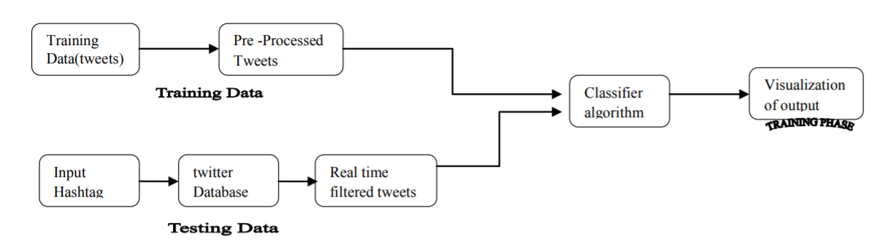

## Figure 7.1: Architecture diagram

## Here first we collect the data sets and process the data and we remove if there are any impurities in the data sets. Next the data is normalized if needed like it can be converted to smaller volume of data. Next the data is converted to supporting format. And then it is stored in the databases. Next the required method is applied. Now we get the final results.

## 7.2 DATA FLOW DIAGRAMS

## Data Flow Diagram can also be termed as bubble chart. It is a pictorial or graphical form, which can be applied to represent the input data to a system and multiple functions carried out on the data and the generated output by the system.

## A graphical tool accustomed describe and analyze the instant of knowledge through a system manual or automatic together with the method, stores of knowledge, and delays within the system. The transformation of knowledge from input to output, through processes, is also delineate logically and severally of the physical elements related to the system. The DFD is also known as a data flow graph or a bubble chart.The BasicNotation used to create a DFD’s are as follows:

* **Dataflow:**





* **Process:**

.



* **Source:**
* **Data Store:**

 

* **Rhombus**: decision

**7.3 UML DIAGRAMS**

The Unified Modeling Language allows the software engineer to express an analysis model using the modeling notation that is governed by a set of syntactic semantic and pragmatic rules.

A UML system is represented using five different views that describe the system from distinctly different perspective. Each view is defined by a set of diagram, which is as follows.

**User Model View**

This view represents the system from the users perspective. The analysis representation describes a usage scenario from the end-users perspective.

**Structural Model view**

In this model the data and functionality are arrived from inside the system. This model view models the static structures.

**Behavioral Model View**

It represents the dynamic of behavioral as parts of the system, depicting the interactions of collection between various structural elements described in the user model and structural model view.

**Implementation Model View**

In this the structural and behavioral as parts of the system are represented as they are to be built.

**5.3.1 USE CASE DIAGRAM**

A use case diagram at its simplest is a representation of a user's interaction with the system and depicting the specifications of a use case. A use case diagram can portray the different types of users of a system and the various ways that they interact with the system. This type of diagram is typically used in conjunction with the textual use case and will often be accompanied by other types of diagrams as well.

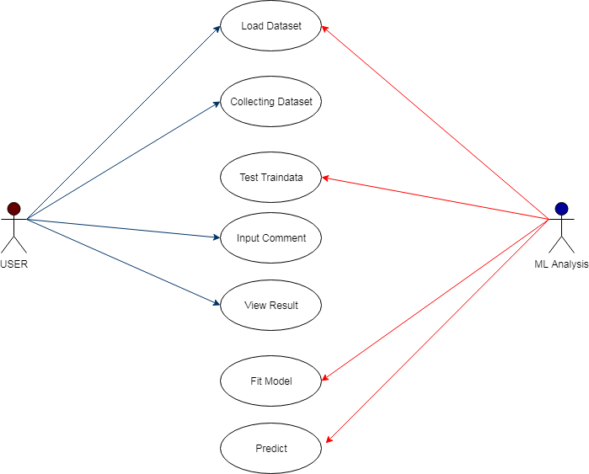

Figure 7.3.1 Use Case Diagram

* + 1. **CLASS DIAGRAM**

The class diagram is the main building block of object oriented modeling. It is used both for general conceptual modeling of the systematic of the application, and for detailed modeling translating the models into programming code. Class diagrams can also be used for data modeling. The classes in a class diagram represent both the main objects, interactions in the application and the classes to be programmed. A class with three sections, in the diagram, classes is represented with boxes which contain three parts:

The upper part holds the name of the class

The middle part contains the attributes of the class

The bottom part gives the methods or operations the class can take or undertake.

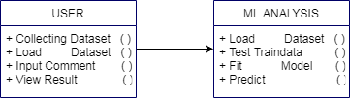

Figure 7.3.2: Class Diagram.

## 5.3.3 SEQUENCEDIAGRAM

A sequence diagram is a kind of interaction diagram that shows how processes operate with one another and in what order. It is a construct of a Message Sequence Chart. A sequence diagram shows object interactions arranged in time sequence. It depicts the objects and classes involved in the scenario and the sequence of messages exchanged between the objects needed to carry out the functionality of the scenario. Sequence diagrams are typically associated with use case realizations in the Logical View of the system under development. Sequence diagrams are sometimes called event diagrams, event scenarios, and timing diagrams.

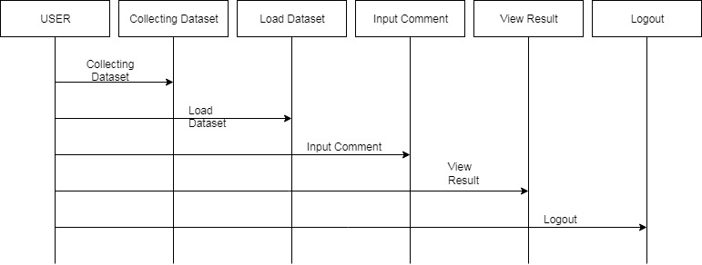

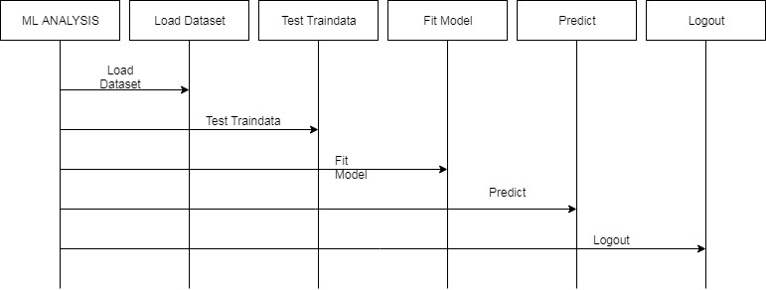

Figure 7.3.3: Sequence diagram

## 5.3.4 ACTIVITY DIAGRAM

Activity diagrams are graphical representations of workflows of stepwise activities and actions with support for choice, iteration and concurrency. In the Unified Modeling Language, activity diagrams can be used to describe the business and operational step-by-step workflows of components in a system. An activity diagram shows the overall flow of control.

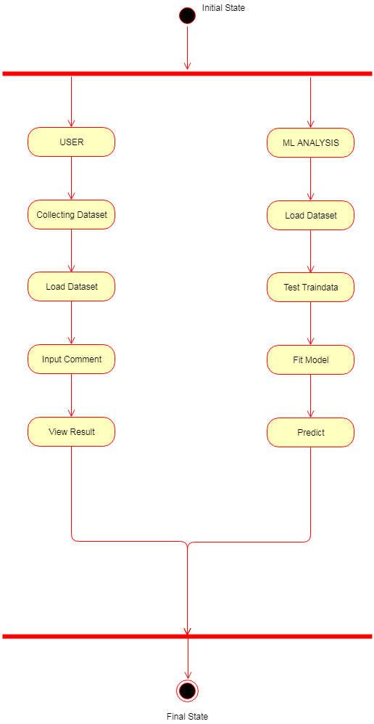

Figure 7.3.4: Activity Diagram

**Component Diagram**

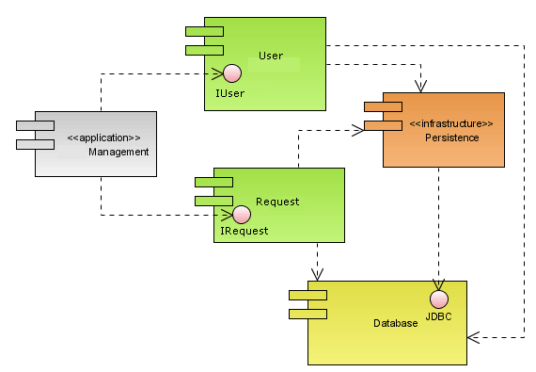**Deployment Diagram**

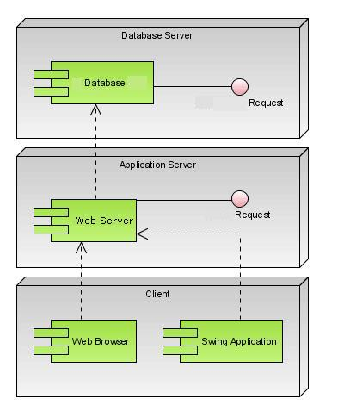

**8. TESTING**

## Testing is the process where the test data is prepared and is used for testing the modules individually and later the validation given for the fields. Then the system testing takes place which makes sure that all components of the system property functions as a unit. The test data should be chosen such that it passed through all possible condition. The following is the description of the testing strategies, which were carried out during the testing period.

## 8.1 SYSTEM TESTING

## Testing has become an integral part of any system or project especially in the field of information technology. The importance of testing is a method of justifying, if one is ready to move further, be it to be check if one is capable to with stand the rigors of a particular situation cannot be underplayed and that is why testing before development is so critical. When the software is developed before it is given to user to user the software must be tested whether it is solving the purpose for which it is developed. This testing involves various types through which one can ensure the software is reliable. The program was tested logically and pattern of execution of the program for a set of data are repeated. Thus the code was exhaustively checked for all possible correct data and the outcomes were also checked.

## 8.2 MODULE TESTING

## To locate errors, each module is tested individually. This enables us to detect error and correct it without affecting any other modules. Whenever the program is not satisfying the required function, it must be corrected to get the required result. Thus all the modules are individually tested from bottom up starting with the smallest and lowest modules and proceeding to the next level. Each module in the system is tested separately. For example the job classification module is tested separately. This module is tested with different job and its approximate execution time and the result of the test is compared with the results that are prepared manually. Each module in the system is tested separately. In this system the resource classification and job scheduling modules are tested separately and their corresponding results are obtained which reduces the process waiting time.

## 8.3 INTEGRATION TESTING

## After the module testing, the integration testing is applied. When linking the modules there may be chance for errors to occur, these errors are corrected by using this testing. In this system all modules are connected and tested. The testing results are very correct. Thus the mapping of jobs with resources is done correctly by the system

## 8.4 ACCEPTANCE TESTING

## When that user fined no major problems with its accuracy, the system passers through a final acceptance test. This test confirms that the system needs the original goals, objectives and requirements established during analysis without actual execution which elimination wastage of time and money acceptance tests on the shoulders of users and management, it is finally acceptable and ready for the operation.

**8.5 TEST CASES:**

|  |  |  |  |  |  |  |  |
| --- | --- | --- | --- | --- | --- | --- | --- |
| **Test Case Id** | **Test Case Name** | **Test Case Desc.** | **Test Steps** | | | **Test Case Status** | **Test Priority** |
| **Step** | **Expected** | **Actual** |
| 01 | Upload the tasks dataset | Verify either file is loaded or not | If dataset is not uploaded | It cannot display the file loaded message | File is loaded which displays task waiting time | High | High |
| 02 | Upload live video | Verify either dataset loaded or not | If dataset is not uploaded | It cannot display dataset reading process completed | It can display dataset reading process completed | low | High |
| 03 | Preprocessing | Whether preprocessing on the dataset applied or not | If not applied | It cannot  display the necessary data for further process | It can display the necessary data for further process | Medium | High |
| 04 | Prediction Multi model Navie Bayes model | Whether  Prediction algorithm applied on the data or not | If not applied | Multi model Navie Bayes model is created | Multi model Navie Bayes model is created | High | High |
| 05 | Prediction | Whether predicted data is displayed or not | If not displayed | It cannot view prediction tweet sentiment | It can view prediction tweet sentiment | High | High |
| 06 | Noisy Records Chart | Whether the graph is displayed or not | If graph is not displayed | It does not show the variations in between clean and noisy records | It shows the variations in between clean and noisy records | Low | Medium |

TABLE 8.5.1 TESTCASES

1. **SCREEN SHOTS**

**10. CONCLUSION**

The provided tweets were a mixture of words, emoticons, URLs, hashtags, user mentions, and symbols. Before training the dataset we pre-processed the tweets to make it suitable for feeding into models. We implemented machine learning algorithms Naive Bayes Classifier to classify the polarity of the tweet. We used three types of features namely unigrams, bigrams and trigrams for classification and observed that augmenting the feature vector with bigrams improved the accuracy and trigrams degraded the accuracy. Once the feature has been extracted it was represented as a sparse vector. It has been observed that presence in the sparse vector representation recorded a better performance than frequency. We finally achieved an accuracy of 76.78%

With unigram and bigram, without any normalization, stop words or tf-idf

Our model accuracy : 0.76788

Leaderboard highest : 0.79249

**Future Enhancements:**

* Handling emotion ranges: We can improve and train our models to handle a range of sentiments. Tweets don’t always have positive or negative sentiment. At times they may have no sentiment i.e. neutral. Sentiment can also have gradations like the sentence, ‘This is good’, is positive but the sentence, ‘This is extraordinary’, is somewhat more positive than the first. We can therefore classify the sentiment in ranges, say from -2 to +2.
* Using hashtags and other symbols like ‘?’ and ‘!’: During our pre-processing, we discard most of the symbols like hashtags, question marks and exclamation marks. These symbols may be helpful in assigning sentiment to a sentence.

Text Processing and Sentiment analysis emerges as a challenging field with lots of obstacles as it involves natural language processing. It has a wide variety of applications that could benefit from its results, such as news analytics, marketing, question answering, readers do. Getting important insights from opinions expressed on the internet especially from social media blogs is vital for many companies and institutions, whether it is in terms of product feedback, public mood, or investors opinions.

**11. REFERENCES**

* S. Madisetty and M. S. Desarkar, “A neural network-based ensemble approach for spam detection in Twitter,” IEEE Trans. Comput. Social Syst., vol. 5, no. 4, pp. 973–984, Dec. 2018.
* H. B. Kazemian and S. Ahmed, “Comparisons of machine learning techniques for detecting malicious webpages,” Expert Syst. Appl., vol. 42, no. 3, pp. 1166–1177, Feb. 2015.
* H. Gupta, M. S. Jamal, S. Madisetty, and M. S. Desarkar, “A framework for real-time spam detection in Twitter,” in Proc. 10th Int. Conf. Commun. Syst. Netw. (COMSNETS), Jan. 2018, pp. 380–383.
* T. Wu, S. Liu, J. Zhang, and Y. Xiang, “Twitter spam detection based on deep learning,” in Proc. Australas. Comput. Sci. Week Multiconf. (ACSW), 2017, p. 3.
* Y. Boshmaf, I. Muslukhov, K. Beznosov, and M. Ripeanu, “Key challenges in defending against malicious socialbots,” Presented at the 5th USENIX Workshop Large-Scale Exploits Emergent Threats, 2012, pp. 1–4.
* G. Yan, “Peri-watchdog: Hunting for hidden botnets in the periphery of online social networks,” Comput. Netw., vol. 57, no. 2, pp. 540–555, Feb. 2013

**BIBLIOGRAPHY**

python Technologies

python Complete Reference

*python* Script Programming by Yehuda Shiran

Mastering *python* Security

*python* Professional by Shadab siddiqui

*python* server pages by Larne Pekowsley

*python* Server pages by Nick Todd

HTML

HTML Black Book by Holzner

sqllite

## 

## SAMPLE CODE

# USAGE

# python train_mask_detector.py --dataset dataset

# import the necessary packages

from tensorflow.keras.preprocessing.image import ImageDataGenerator

from tensorflow.keras.applications import MobileNetV2

from tensorflow.keras.layers import AveragePooling2D

from tensorflow.keras.layers import Dropout

from tensorflow.keras.layers import Flatten

from tensorflow.keras.layers import Dense

from tensorflow.keras.layers import Input

from tensorflow.keras.models import Model

from tensorflow.keras.optimizers import Adam

from tensorflow.keras.applications.mobilenet_v2 import preprocess_input

from tensorflow.keras.preprocessing.image import img_to_array

from tensorflow.keras.preprocessing.image import load_img

from tensorflow.keras.utils import to_categorical

from sklearn.preprocessing import LabelBinarizer

from sklearn.model_selection import train_test_split

from sklearn.metrics import classification_report

from imutils import paths

import matplotlib.pyplot as plt

import numpy as np

import argparse

import os

# construct the argument parser and parse the arguments

ap = argparse.ArgumentParser()

ap.add_argument("-d", "--dataset", required=True,

help="path to input dataset")

ap.add_argument("-p", "--plot", type=str, default="plot.png",

help="path to output loss/accuracy plot")

ap.add_argument("-m", "--model", type=str,

default="mask_detector.model",

help="path to output face mask detector model")

args = vars(ap.parse_args())

# initialize the initial learning rate, number of epochs to train for,

# and batch size

INIT_LR = 1e-4

EPOCHS = 20

BS = 32

# grab the list of images in our dataset directory, then initialize

# the list of data (i.e., images) and class images

print("[INFO] loading images...")

imagePaths = list(paths.list_images(args["dataset"]))

data = []

labels = []

# loop over the image paths

for imagePath in imagePaths:

# extract the class label from the filename

label = imagePath.split(os.path.sep)[-2]

# load the input image (224x224) and preprocess it

image = load_img(imagePath, target_size=(224, 224))

image = img_to_array(image)

image = preprocess_input(image)

# update the data and labels lists, respectively

data.append(image)

labels.append(label)

# convert the data and labels to NumPy arrays

data = np.array(data, dtype="float32")

labels = np.array(labels)

# perform one-hot encoding on the labels

lb = LabelBinarizer()

labels = lb.fit_transform(labels)

labels = to_categorical(labels)

# partition the data into training and testing splits using 75% of

# the data for training and the remaining 25% for testing

(trainX, testX, trainY, testY) = train_test_split(data, labels,

test_size=0.20, stratify=labels, random_state=42)

# construct the training image generator for data augmentation

aug = ImageDataGenerator(

rotation_range=20,

zoom_range=0.15,

width_shift_range=0.2,

height_shift_range=0.2,

shear_range=0.15,

horizontal_flip=True,

fill_mode="nearest")

# load the MobileNetV2 network, ensuring the head FC layer sets are

# left off

baseModel = MobileNetV2(weights="imagenet", include_top=False,

input_tensor=Input(shape=(224, 224, 3)))

# construct the head of the model that will be placed on top of the

# the base model

headModel = baseModel.output

headModel = AveragePooling2D(pool_size=(7, 7))(headModel)

headModel = Flatten(name="flatten")(headModel)

headModel = Dense(128, activation="relu")(headModel)

headModel = Dropout(0.5)(headModel)

headModel = Dense(2, activation="softmax")(headModel)

# place the head FC model on top of the base model (this will become

# the actual model we will train)

model = Model(inputs=baseModel.input, outputs=headModel)

# loop over all layers in the base model and freeze them so they will

# *not* be updated during the first training process

for layer in baseModel.layers:

layer.trainable = False

# compile our model

print("[INFO] compiling model...")

opt = Adam(lr=INIT_LR, decay=INIT_LR / EPOCHS)

model.compile(loss="binary_crossentropy", optimizer=opt,

metrics=["accuracy"])

# train the head of the network

print("[INFO] training head...")

H = model.fit(

aug.flow(trainX, trainY, batch_size=BS),

steps_per_epoch=len(trainX) // BS,

validation_data=(testX, testY),

validation_steps=len(testX) // BS,

epochs=EPOCHS)

# make predictions on the testing set

print("[INFO] evaluating network...")

predIdxs = model.predict(testX, batch_size=BS)

# for each image in the testing set we need to find the index of the

# label with corresponding largest predicted probability

predIdxs = np.argmax(predIdxs, axis=1)

# show a nicely formatted classification report

print(classification_report(testY.argmax(axis=1), predIdxs,

target_names=lb.classes_))

# serialize the model to disk

print("[INFO] saving mask detector model...")

model.save(args["model"], save_format="h5")

# plot the training loss and accuracy

N = EPOCHS

plt.style.use("ggplot")

plt.figure()

plt.plot(np.arange(0, N), H.history["loss"], label="train_loss")

plt.plot(np.arange(0, N), H.history["val_loss"], label="val_loss")

plt.plot(np.arange(0, N), H.history["acc"], label="train_acc")

plt.plot(np.arange(0, N), H.history["val_acc"], label="val_acc")

plt.title("Training Loss and Accuracy")

plt.xlabel("Epoch #")

plt.ylabel("Loss/Accuracy")

plt.legend(loc="lower left")

plt.savefig(args["plot"])